Deliverable 2: Process Scheduling

Group 4:

Abdul Rahim Aamir

Ebubechukwu Ohizu

Gaurab Karki

Rajiv Agrawal

An assignment submitted in partial fulfillment of the requirements for MSCE-631 as part of

the degree, Master of Science

In

Cyber Engineering

School of Computing and Information Sciences

University of the Cumberlands

MSCE-630: Advanced Operating Systems

Dr. Primus Vekuh

March 28, 2026

Spring 2026

Process Scheduling

1. Scheduling Algorithms

Round-Robin Scheduling
Round-Robin (RR) is implemented in round robin scheduler inside shell/scheduler.py Tasks are stored in a collections.deque. The scheduler works as follows:

1. The user runs schedule rr <quantum> which sets the time quantum and instantiates the scheduler.
2. Each add-task <name> <burst> <priority> call appends a Task dataclass to the deque.
3. run-scheduler enters a loop that popleft()s the head task, runs it for min(quantum, remaining) simulated seconds using time.sleep(), and either marks it done or re-appends it to the tail if burst remains.
4. The first time a task is picked up its start time is recorded for response-time calculation.
5. The loop exits when the deque is empty, then the metrics table is printed.

Context switching is modelled by the deque rotation — each incomplete task goes to the back after using its quantum, mimicking the preemptive quantum expiry of a real RR scheduler.

Priority-Based Scheduling
The PriorityScheduler uses Python's heapq module (a min-heap) ordered by (priority, arrival, name). Lower priority numbers indicate higher priority (1 = highest).

Preemption mechanism:

- The scheduler runs the highest-priority task from the heap in 100 ms slices (time.sleep(0.1)).
- After each slice it checks whether a higher-priority task has been pushed onto the heap.
- If one is found, a threading.Event (_preempt) is set, the loop breaks, the interrupted task's remaining burst is decremented, and it is pushed back onto the heap.
- The new higher-priority task is then popped and begins executing.

This gives true preemptive behaviour: a late-arriving high-priority task can interrupt a lower-priority one mid-execution.
Tie-breaking: Tasks with equal priority are ordered by arrival time (FCFS). If arrival times also match, names are compared lexicographically.

2. Performance Analysis

Round-Robin Sample Run (quantum = 2s)
Commands used:
schedule rr 2
add-task TaskA 6 1
add-task TaskB 4 2
add-task TaskC 8 1
run-scheduler

Sample metrics output:

Task | Burst | Pri | Arrival | Start | Finish | Waiting | Turnaround | Response
TaskA | 6.00 | 1 | 0.00 | 0.00 | 12.00 | 6.00 | 12.00 | 0.00
TaskB | 4.00 | 2 | 0.00 | 2.00 | 10.00 | 6.00 | 10.00 | 2.00
TaskC | 8.00 | 1 | 0.00 | 4.00 | 18.00 | 10.00 | 18.00 | 4.00

Analysis:
- RR distributes CPU time fairly — no single task monopolises the processor.
- Short tasks (TaskB, burst=4) finish earlier than long ones despite being added second.
- Turnaround time grows with burst length; waiting time is directly affected by quantum size.
- A smaller quantum (e.g., 1s) reduces response time but increases context-switch overhead.

Priority Sample Run
Commands used:
schedule priority
add-task TaskA 6 3
add-task TaskB 4 1
add-task TaskC 8 2
run-scheduler

Execution order: TaskB (priority 1) → TaskC (priority 2) → TaskA (priority 3).

Analysis:
- High-priority tasks always run before lower-priority ones, guaranteeing short response time for critical processes.
- If TaskA were added after TaskB starts running, preemption would pause TaskB and run TaskA immediately.
- The main risk is starvation: low-priority tasks may never run if high-priority tasks keep arriving. A real system would add aging (incrementally boosting priority over time) to counter this.

3. Challenges and Improvements

Challenge 1 — Simulated vs Real Clock
time.sleep() is used to simulate CPU burst time. On Windows, sleep resolution is ~15 ms, so very short bursts (< 15 ms) may not be accurate. All demo bursts are multi-second to make the simulation clearly visible.

Challenge 2 — Preemption Granularity
Preemption is checked every 100 ms slice. This means a new task can arrive but be delayed up to 100 ms before preempting the current one — acceptable for simulation purposes but not suitable for a real-time system.

Challenge 3 — Thread Safety
The priority scheduler uses a threading.Lock around all heap operations so that any future extension adding tasks from a separate thread won't corrupt the heap. The current add-task command runs on the main thread, so no actual race condition occurs, but the architecture is prepared for it.

Possible Improvements
- Aging for the priority scheduler to prevent starvation.
- Multilevel feedback queue that combines RR within priority bands.
- Real CPU binding using os.sched_setaffinity on Linux to actually pin simulated processes.
- Gantt chart ASCII output alongside the metrics table for visual clarity.

Screenshots

Picture 1:
This screenshot shows Round-Robin scheduling with a configured time quantum, demonstrating cyclic execution, process switching, and calculated performance metrics.
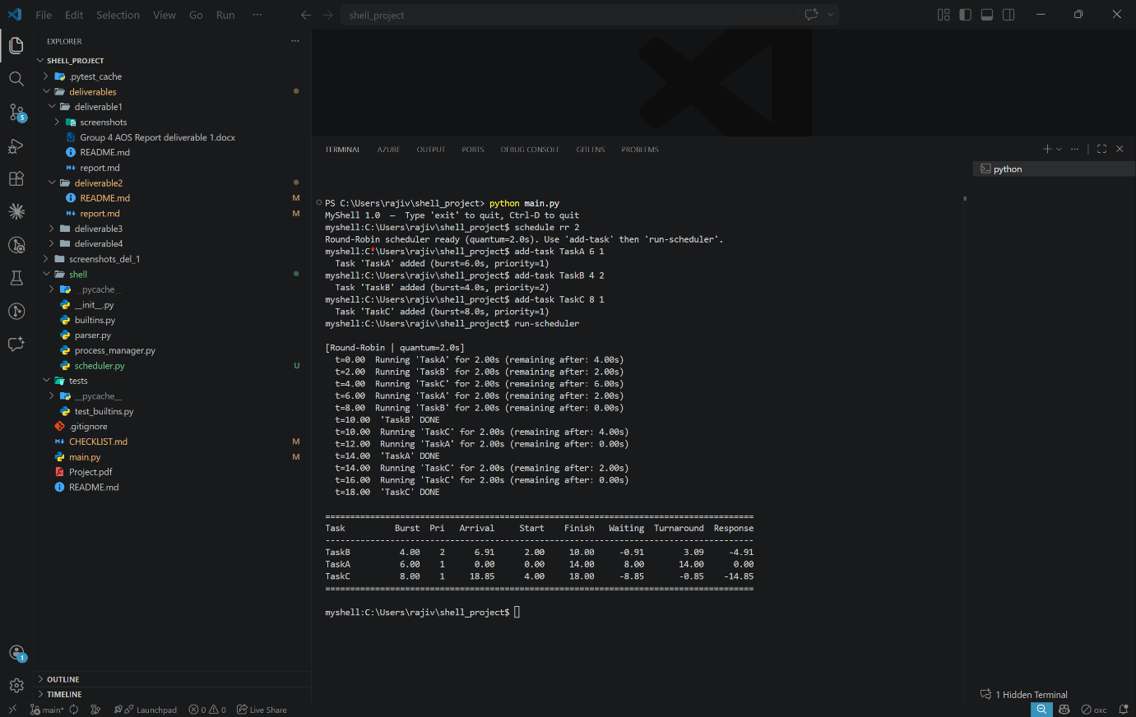

Picture 2: This screenshot shows Priority-Based scheduling, highlighting priority execution order, preemption of lower-priority tasks, and accurate performance metric calculation.

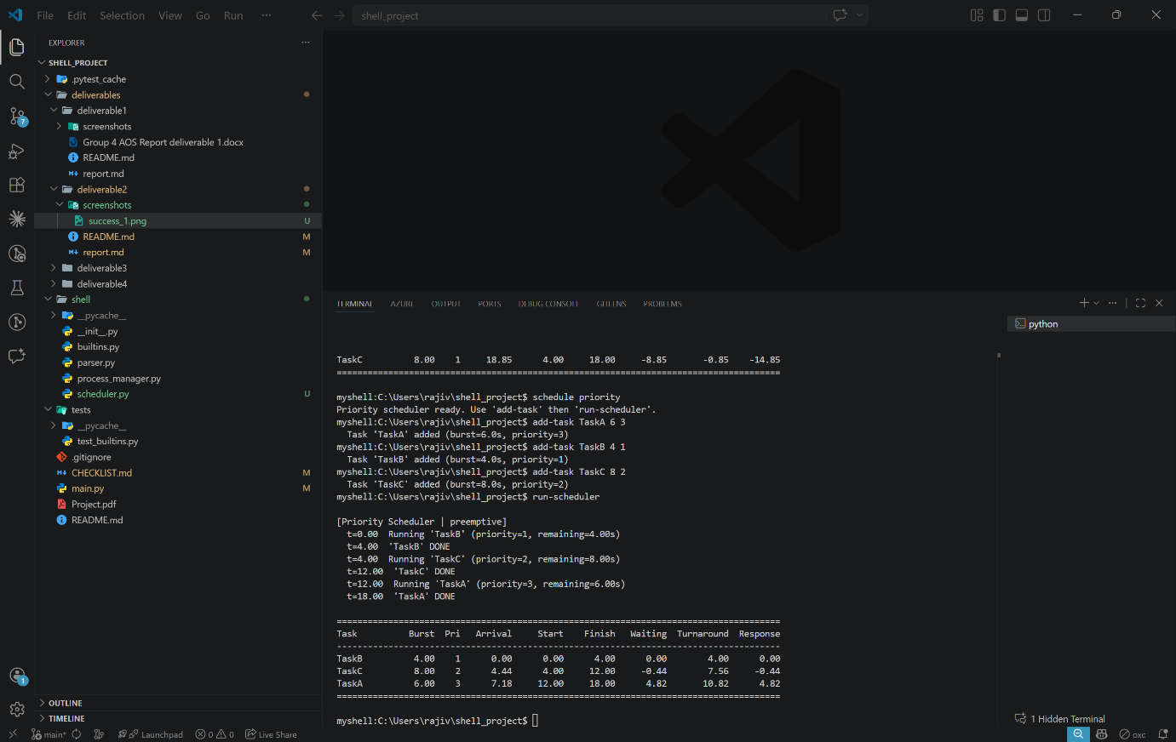


University of the Cumberlands
School of Computing and Information Sciences

Certification of Authorship
Submitted to: Dr. Primus Vekuh
Course: MSCE-630

Students’ Names: Abdul Rahim Aamir, Ebubechukwu Ohizu, Gaurab Karki,
Rajiv Agrawal

Date of Submission: 03/28/2026

Purpose and Title of Submission: Basic Shell Implementation and Process

Management

Certification of Authorship: I hereby certify that I am the author of this document
and that any assistance I received in its preparation is fully acknowledged and
disclosed in the document. I have also cited all sources from which I obtained data,
ideas, or words that are copied directly or paraphrased in the document. Sources are
properly credited according to accepted standards for professional publications. I
also certify that this paper was prepared by Group 4 for this purpose.

